Sana’a
UNIVERSITY



FACULTY OF ENGINEERING

Mechatronics Department

Second Year

Report
Thermal Simulation in Solid work

Supervision
Prof. Hamod Alnhary
Eng. Asim

Adopted by

Ibrahim Alkhlydy 202073007
Abdulrhman Al-aghbari 202073119
Mechatronics (Parallel)

Table of Contents

Introduction............................................................................................................... ............. 1

Objecti........................................................................................................................................ 2

Methodology ...................................................................................................................... 3

Equipment........................................................................................................................... 4

Procedures........................................................................................................................... 5

Simulation........................................................................................................................... 6

Results.................................................................................................................................. 7
Graph………………………………………………………………………………….7

Obstacles….................................................................................................... 8

References.............................................................................................................................................................. 9

Introduction:

The experience to learn how we can make simulation for the (conduction or convection or radiation) and make all of this in the Solid Work And from the Solid work I make my project. My project is from cop . The cop made of (glass) and how transmission the heat in the materials

Objectives:

The objective of the project how to make simulation in solid work and how the hat transmission in the materials.

Methodology:

The methodology is a simulation of the heat transmission in the materials And the calibration of the heat

Equipment:

The matter is glass

Procedures:

First: Draw the 2D
Second: Draw the 3D
Third: make the thermal conduction

- Simulation
The full project in the solid work

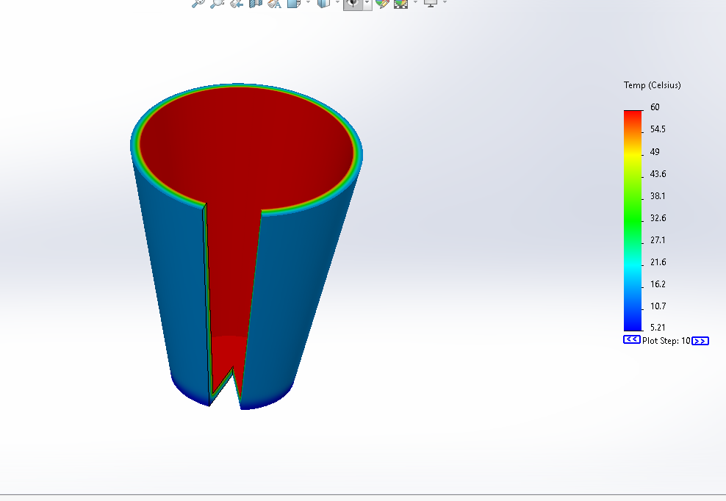

Step one

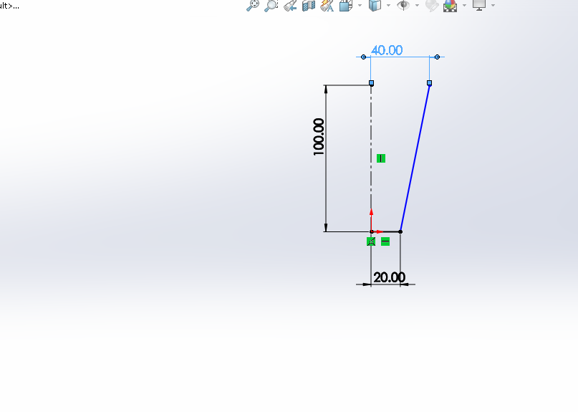
Step two
3D sketch

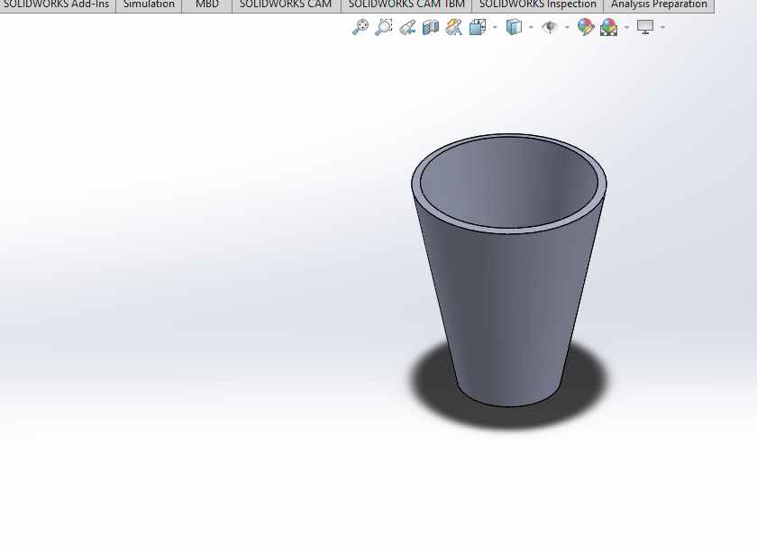
Step three

Make a 2d thermal

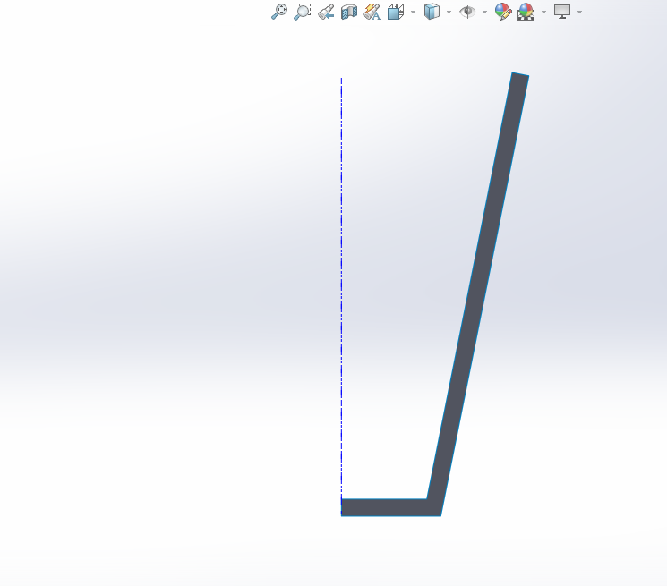

Step four
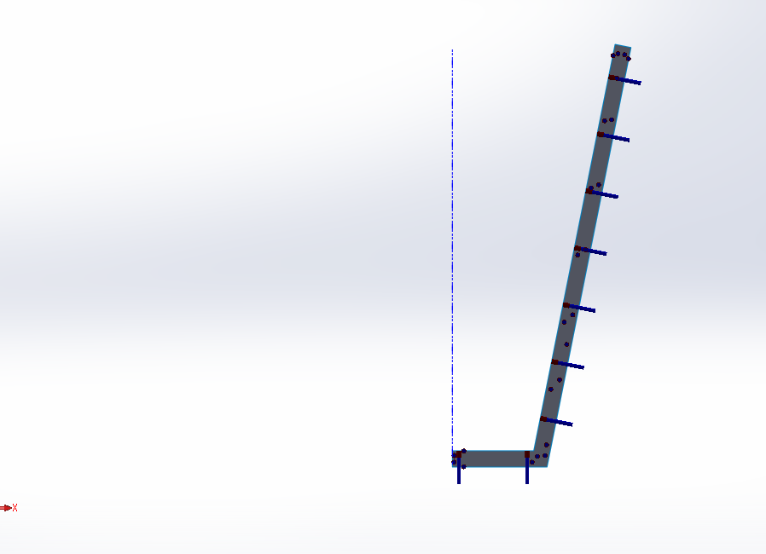

Step five
Property of material
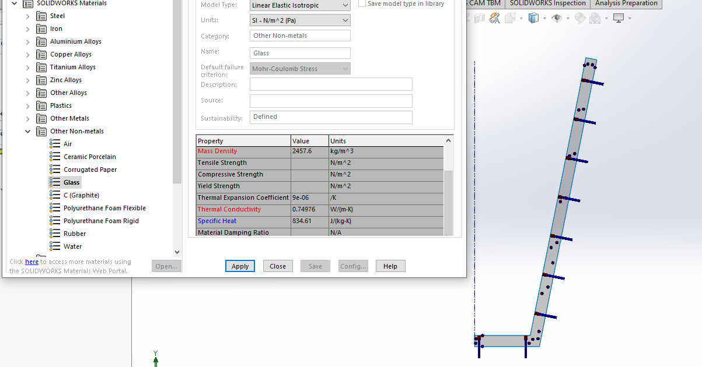

Step Six
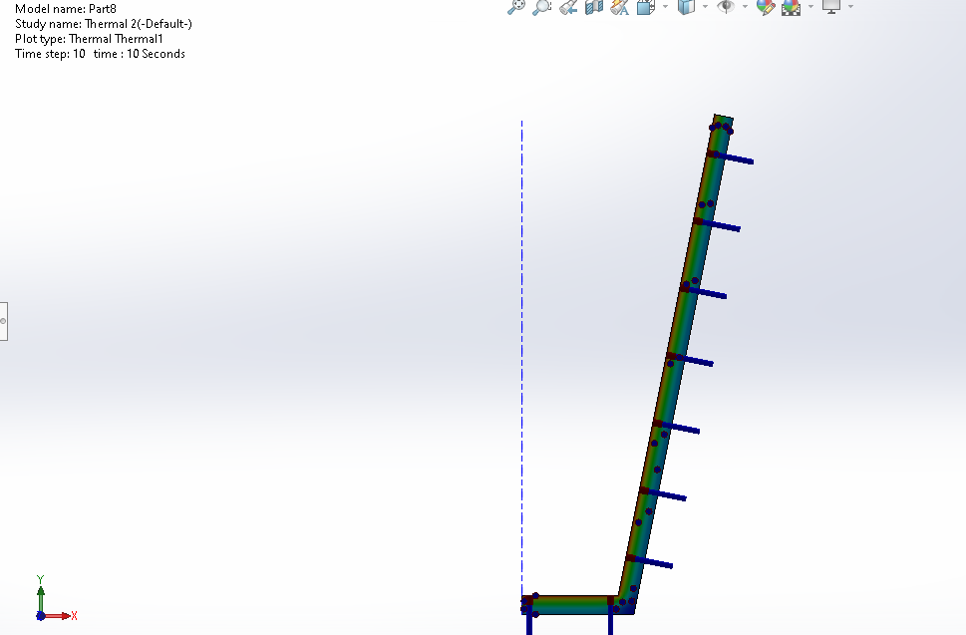

Step seven

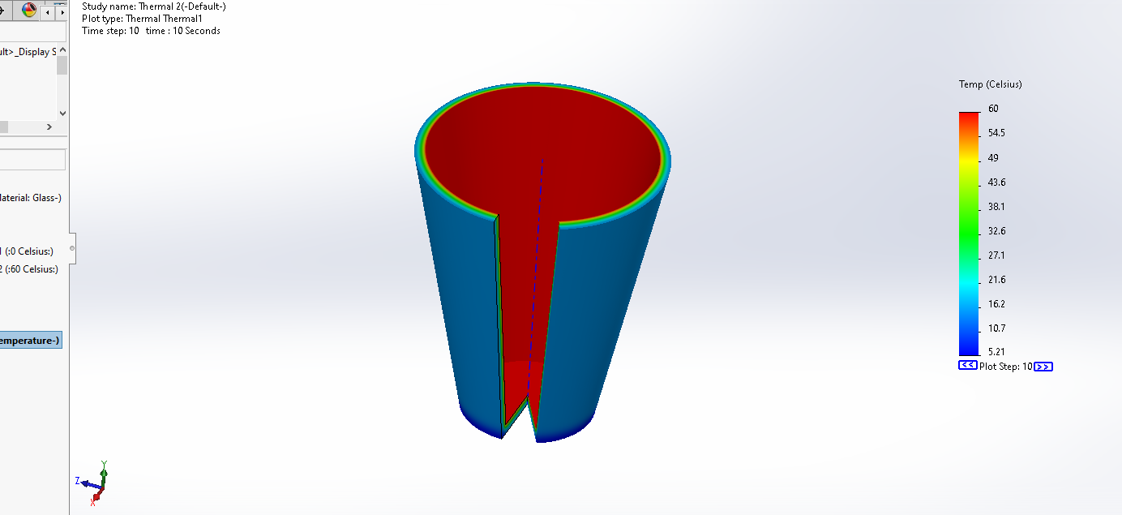

Step eight
Simulation of heat transfer
1)


2)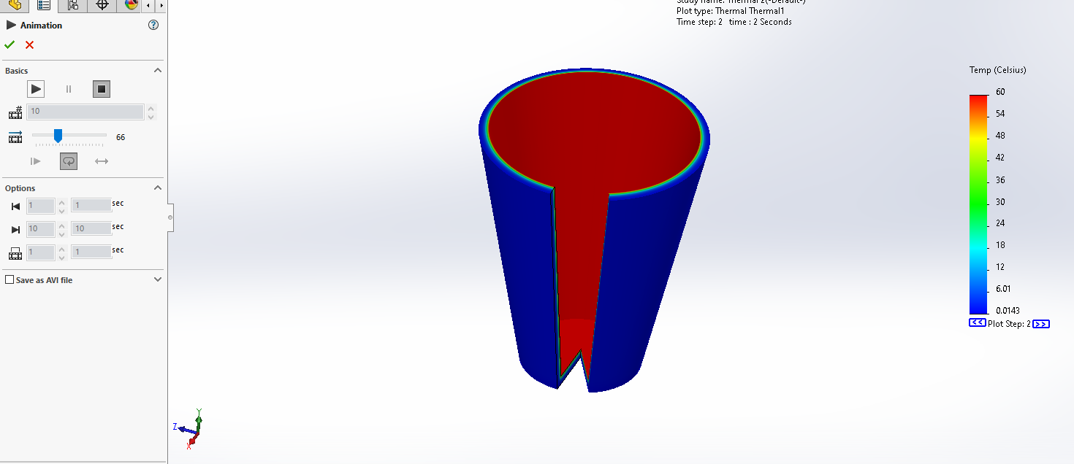

3)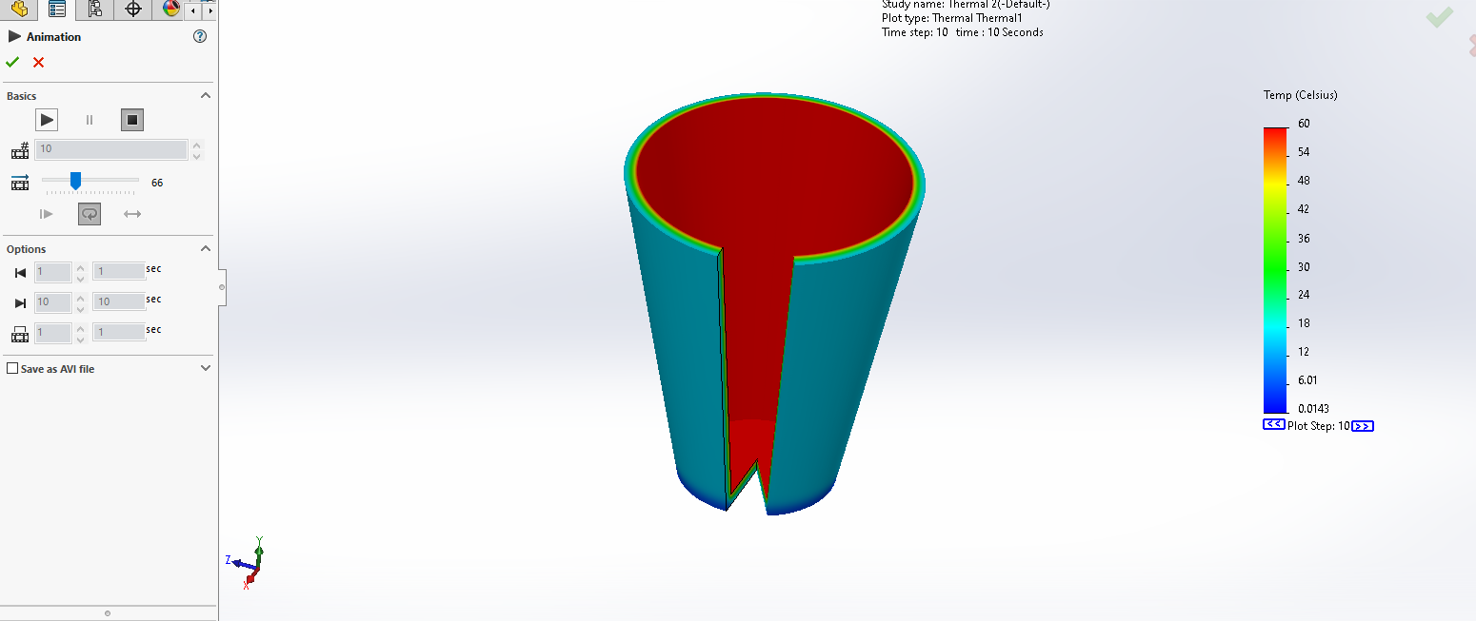

Step nine
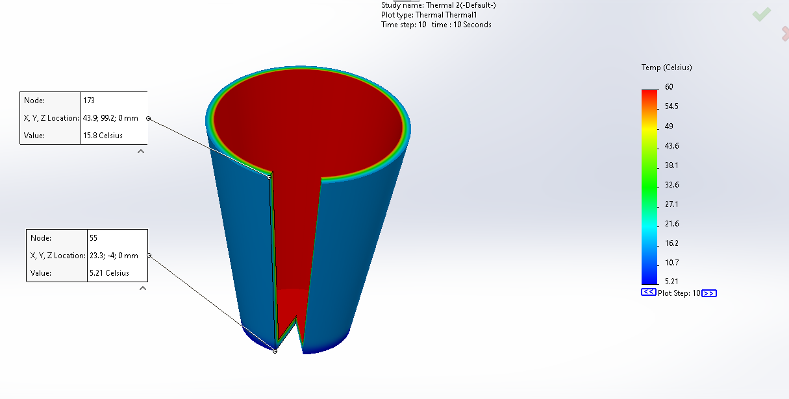

Step ten
Simulation of heat

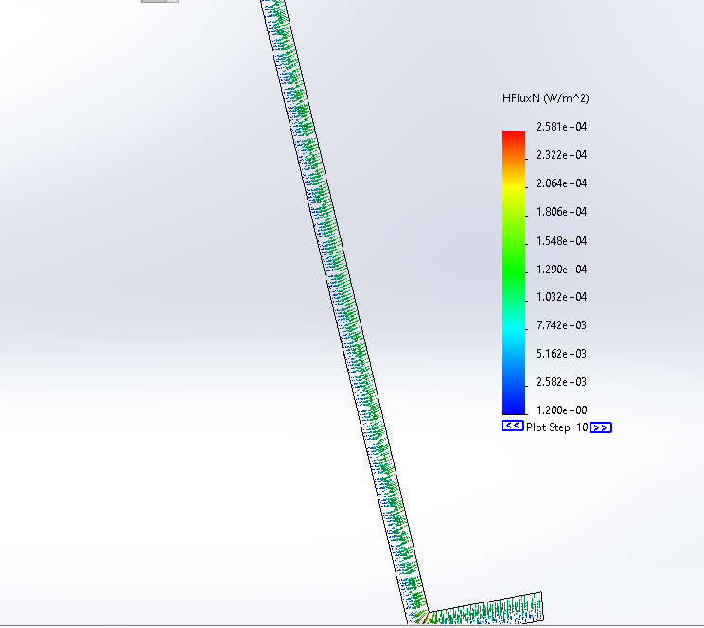

- Rules
Q) The (cap) shows a conical section fabricated from (glass). It is of conical cross section having diameter D = ax1/2, where a = 0.7 m1/2. The small end is located at x1 =15 mm and the large end at x2= 100mm. The end temperatures are T1= 340 K and T2 = 283 K, while the lateral surface is well insulated. Calculate the heat rate qx.
KNOWN: Conduction in a conical section with prescribed diameter, D, as a function of x in the form D = ax1/2
FIND: (a) Heat transfer rate, qx
SCHEMATIC:
100mm

40mm
ASSUMPTIONS: (1) Steady-state conditions, (2) One-dimensional conduction in x-direction
(3)the T1=340k, T2=283k (4)K=0.8 w/m.k (5)X=100mm , x2=15mm

PROPERTIES: Glass: k= 0.8 W/m⋅K.
ANALYSIS:
Qx=-kAdT/dx=-k[π(ax^1/2)^2/4]dT/dx
Using A= πD^2/4 where D=ax^1/2
4qx/πa^2k$\sum_{x=1}^{x}{dx/x}$=$\sum_{T=1}^{T}{}$dt
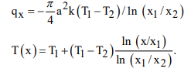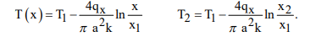
So: qx=π/4*0.7^2m*0.8(340-283) ln15/100=33.2kw

BY hand | BY simulation
T1=283k | T1=278.15k
T2=340k | T2=333.15k
K=0.8w/m.k | K=0.74976

Graph
- Glass
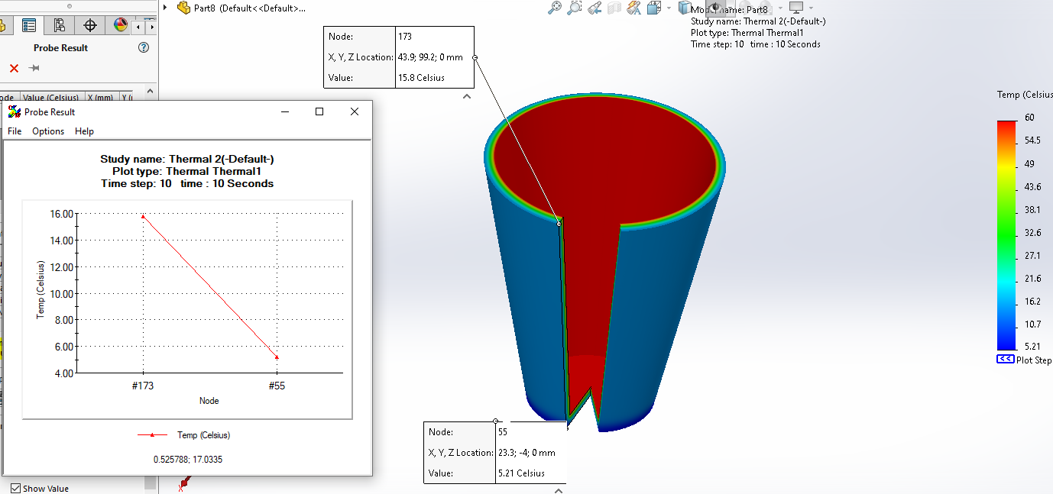

The graph of in and out

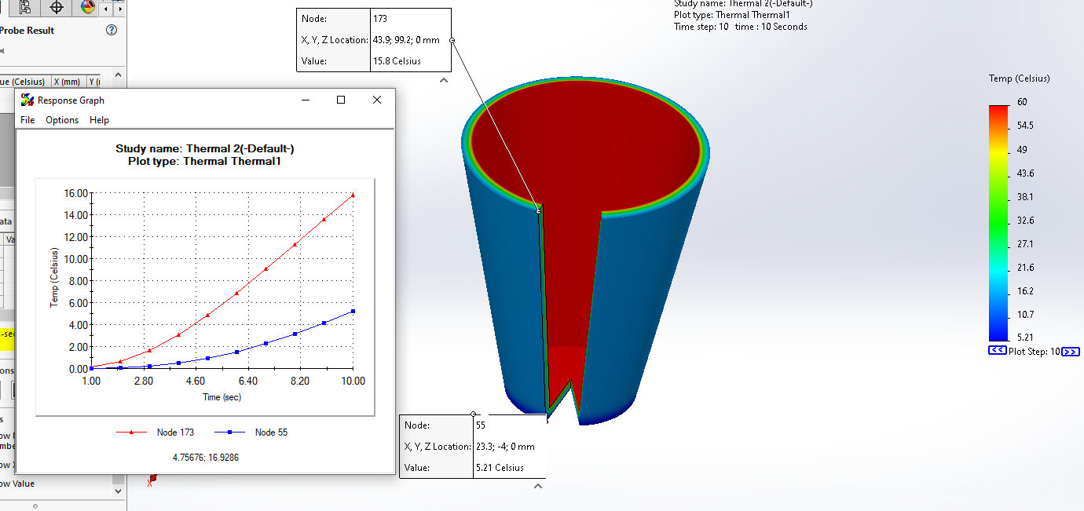

Obstacles:
1) The first obstacle is when I assembly my project it is nor running I do not know what happened
2) The second thing is I do not know how to make a thermal Simulation but in the end I get it
3) In the end. The biggest thing is how to choose the mettles
And how to simulation it in solid work

- References:
From You top and Google

